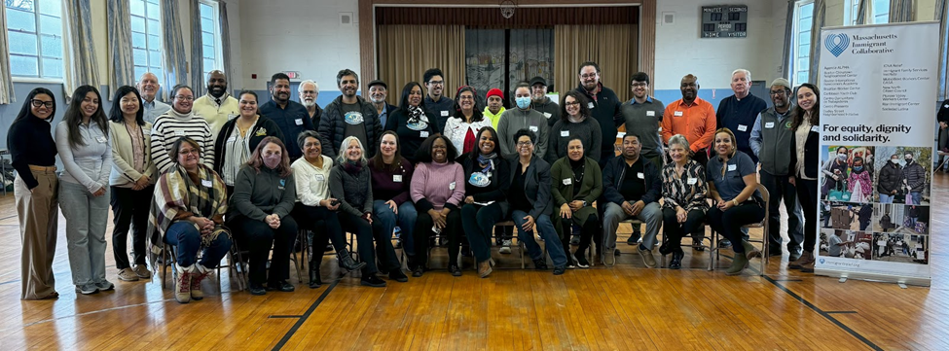

**Looking back to move forward**

The Massachusetts Immigrant Collaborative is grateful to you, our supporters, for helping us to empower 4,447 people from immigrant communities. On behalf of all 15 Collaborative partners, thank you!

We began 2024 by coming together for our annual retreat and spent the day sharing our accomplishments, what we learned in 2023, and how these learnings will shape our priorities going forward. Most importantly, we heard about each other’s successes, challenges, the communities each of us serves and how each partner supports and empowers them. Some serve as welcome centers for newcomers arriving daily, connecting them to shelter and resources. Several offer hunger relief including bulk food distribution and meals; and others provide education and leadership opportunities for young immigrants. We learned about the need to advocate for workers’ rights and educate immigrant workers experiencing wage theft and other exploitation. In 2023, migrant farm workers in the western part of the state lost jobs when record-breaking floods destroyed farmland during the summer growing season. Our partners in the Pioneer Valley were there to support them. Throughout Massachusetts, whether greater Boston, Middlesex County, Pioneer Valley or New Bedford, our partners are working with a growing immigrant population in need of housing, health and other services.

Our take-away is that working together, our 15 partner organizations can learn from each other, sharing knowledge, skills and best practices, and can advocate more powerfully for fair immigration policies. Today, the five priorities we identified two years ago remain just as important. In 2024 we will continue to support individuals and families in urgent circumstances by providing **emergency cash and food assistance**. Our **immigration legal services** and **workforce development programs** will empower immigrants seeking stability and better futures. We will work to **build capacity** of each partner organization. Finally, we will increase our **advocacy** efforts and have launched a working group to determine how the Collaborative can best impact policies that affect immigrants. Together we will work toward a better future for all our community members.

🌍🌎🌏

**Immigrant Economic Recovery Initiative: Working toward sustainable futures**

In 2023 the Collaborative began a partnership with the City of Boston Equity and Inclusion Cabinet and launched the **Immigrant Economic Recovery Initiative**, a year-long program empowering 200 immigrant community members in Boston. Each will receive a $600 monthly payment to ease basic needs. Equally important, the program enhances participants' prospects for sustainability by providing an additional $200 for those enrolled in English or skills training courses, along with a household savings incentive match of up to $100.

After extensive outreach and recruitment, we have identified 200 eligible families and individuals from a broad range of cultures, countries of origin, and Boston neighborhoods. Each has been paired with a dedicated case manager tasked with facilitating access to *educational opportunities, conducting goal-setting workshops, assisting with the opening of bank accounts, and connecting participants with additional resources*. We eagerly anticipate supporting these new immigrants as they strive for a more stable and sustainable future.

There is also a research component to this initiative designed to evaluate the impact of direct cash assistance on new immigrants relative to other supportive endeavors. It includes a control group we also recruited for comparison purposes. Leading this aspect of the initiative is the Leah Zalman Center, a local non-profit specializing in immigration research.

To learn more, check out our [press release](https://www.immigrantrelief.org/wp-content/uploads/2024/01/FOR-IMMEDIATE-RELEASE-IERI.pdf) or contact Program Director, Guerlince Semerzier at [gsemerzier@immigrantrelief.org](mailto:gsemerzier@immigrantrelief.org).

🌍🌎🌏

**Immigration Legal Services educate and empower**

For some people, applying for legal immigration status can mean the difference between a work permit and a safe place to call home, and deportation to dangerous circumstances, political unrest or economic challenges. Access to legal counsel can drastically increase a person’s chances for a successful case outcome, yet many cannot afford an attorney.

In collaboration with our legal partners, [Rian Immigrant Center](https://www.riancenter.org/), [Mabel Center for Immigrant Justice](https://www.mabelcenter.org/), and [Agencia ALPHA](https://www.agenciaalpha.org/); and [Immigrant Family Services Institute](https://www.ifsi-usa.org/), who is joining us in this work in 2024 we provide **Centralized Immigration Legal Services**, to which our partners can refer low-income and underserved community members for a free confidential legal consultation. Consultations can educate them about any available legal options. Getting advice from experienced attorneys and Department of Justice (DOJ) accredited representatives who are authorized to practice immigration law helps clients avoid *notarios* or other people who offer assistance but are not authorized to practice law. Following consultations, our legal partners accept cases for full representation as capacity allows, or share additional resources. In 2023 we provided 857 consultations to community members, and full representation to 307. The majority of cases were applications for work permits, or Temporary Protected Status. Though straightforward cases and much less time intensive than some other types, they can have a huge impact, enabling people to remain in the US and support themselves and their families. Other cases like asylum, VAWA, T Visa, U Visa, and Special Immigrant Juvenile Status which gives permanent immigration status to children who cannot reunify with their parent(s) due to abuse, abandonment or neglect; are more resource and time intensive. They are also critically important.

*“Roseline”, referred by the Brazilian Workers Center, shared her experience applying for a visa with support from the Collaborative’s Centralized Immigration Legal Services. Says Roseline, “I know it’s going to be a long process but Beverly [my attorney from Rian] is making it better. [She is] always very attentive [and] always keeps me informed as to what’s going on. It's been extremely positive. Because I have a young child, [having legal services at no cost] helps me a lot. If I had to pay, I wouldn’t be able to go through with the process.”*

*When asked what a potential pathway to legal status means to her, Roseline says, “I have the opportunity to get a work permit, and pay taxes, and have an income. I [could] go back to my country… and visit my friends. My mom … could come, and she could meet her grandchild. Things like that make me very happy.”*

*Roseline shares her message to the Collaborative, its legal partners and community: [I would like to express] gratitude [from] me and my family, for everything that has been done. To have hope… that doesn’t really have a price.”*

🌍🌎🌏

**Emergency assistance remains essential for immigrant families**

When the pandemic began and our 15 partners came together, our main concern was to provide cash and food assistance for families in urgent circumstances. While our focus and programs have expanded, emergency assistance remains a critical need for many.

In 2023, the Collaborative and its partners provided food and emergency cash assistance to 3,590 immigrant families who were experiencing economic hardship. Close to 90% were struggling to pay rent and utilities, and buy food and groceries. Other needs included medical and childcare expenses.

“These resources have made the difference between being housed and unhoused, access to medicines and critical medical care, childcare, and legal services. The significant and necessary work of M.I.C. is sacred work and our families are deeply grateful as we work for a society in which everyone has what we need for lives of dignity and flourishing. Thank you!” said one recipient.

In 2023, increasing numbers of immigrants came to Massachusetts, most seeking escape from violence and political unrest. The partner organizations which comprise the Massachusetts Immigrant Collaborative, in conjunction with the State, are doing their best to support these families, connecting new migrants to needed resources.

🌍🌎🌏

**The big picture: Advocating for a better future**

Looking ahead, the Collaborative seeks to continue its advocacy for policies and better enforcement of existing laws to ensure immigrants are treated with dignity, equity and have a fair chance of building sustainable and successful lives. Many of our partners are currently working on a range of issues around which we plan to become better aligned. We anticipate coming together with more frequency for planning that impacts policies as well as public perception. Additional suggestions from our retreat include reclaiming and restoring the public narrative about immigration; building upon our previous successes in policy advocacy and raising public awareness; exploring how we might work more strategically with the federal government and how they engage with policy and public opinion regarding immigrants.

🌍🌎🌏

**Gratitude to our supporters**

We are grateful for support from our donors in 2023, including the Klarman Family Foundation, Cambridge Community Foundation, The Boston Foundation (through the Executive Office of Housing and Economic Development’s Community Foundations Grant Program for COVID-19 Relief), TJX Foundation, United Way, Liberty Mutual and others whose support enables us to work alongside immigrant families and individuals across Massachusetts.

🌍🌎🌏

**Partner Members of the Collaborative**

The **Massachusetts Immigrant Collaborative** includes 15 partner organizations statewide working in solidarity with under-resourced immigrant communities. By working together, we share ideas, networks and experience, funding and other resources, and support each other in our work.

**José Claudio, from New North Citizens' Council (NNCC - Springfield) and Stephen Hunter from Boston Chinatown Neighborhood Center (BCNC) share their experiences as M.I.C. partners.**

“Mass Immigrant Collaborative has been instrumental for our agency to help the immigrant community get their needs met as they deserve. It has been a blessing for the city of Springfield for NNCC to be partnered with M.I.C. so that we can advocate, build capacity, and provide workforce development that is so much needed in the immigrant community. I cannot be happier to be part of this organization.” - José Claudio, NNCC

“The Collaborative is really important for BCNC because it brings together like-minded organizations who are dealing with the same issues and struggles in the community. It’s really great to collaborate and share resources, experiences and expertise. I can say that I am proud that BCNC is a member of the Collaborative. Working with other partners, we can serve the immigrant community at large.” -Stephen Hunter, BCNC

**You can learn more about our partners by visiting their websites.**

·  [**Agencia ALPHA**](http://www.agenciaalpha.org/)

·  [**Boston Chinatown Neighborhood Center**](https://bcnc.net/)

·  [**Boston International Newcomers Academy**](https://www.bincabps.org/)

·  [**Brazilian Worker Center**](https://www.braziliancenter.org/)

·  [**Caribbean Youth Club**](http://caribbeanyouthclub.org/)

·  [**Centro Comunitario de Trabajadores**](http://cct-newbedford.org/)

·  [**Centro Presente**](https://cpresente.org/)

·  [**Dudley Street Neighborhood Initiative**](https://www.dsni.org/)

·  [**ICNA Relief**](https://www.icnarelief.org/)

·  [**Immigrant Family Services Institute**](https://www.ifsi-usa.org/)

·  [**MetroWest Workers Center: CASA**](http://www.mwc-casa.org/)

·  [**New North Citizen Council**](https://www.newnorthcc.org/)

·  [**Pioneer Valley Workers Center**](https://pvworkerscenter.org/)

·  [**Rian Immigrant Center**](https://riancenter.org/)

·  [**Sociedad Latina**](https://www.sociedadlatina.org/)